Name: SHIVAM TIWARI Roll No: 2520080026
Course: DBMS Practical week 1&2
Practical
Week 1:
A local library is currently managing its books and members using a physical notebook, which has resulted in several operational problems such as misplaced books, difficulty tracking borrowed items, and inaccurate member records. To modernize its operations, the library plans to develop a database system called BookFlow. As a database developer, your task is to create the SQL foundation for this system. First, create a new database named bookflow_db. Then, design two tables: a Books table containing the columns book_id, title, isbn, and published_year, and a Members table containing the columns member_id, full_name, and email. Ensure data integrity by setting book_id and member_id as PRIMARY KEYs, applying a NOT NULL constraint to the title column so that every book must have a name, enforcing UNIQUE constraints on both isbn and email to prevent duplicate entries, and adding a CHECK constraint to ensure that the published_year is not in the future (for example, it must be less than 2027). Finally, insert three sample records into both the Books and Members tables to verify that the database structure and constraints are functioning correctly. This exercise will help you develop skills in schema definition, data integrity enforcement, and the use of SQL Data Definition Language (DDL) commands such as CREATE DATABASE, CREATE TABLE, and INSERT statements.
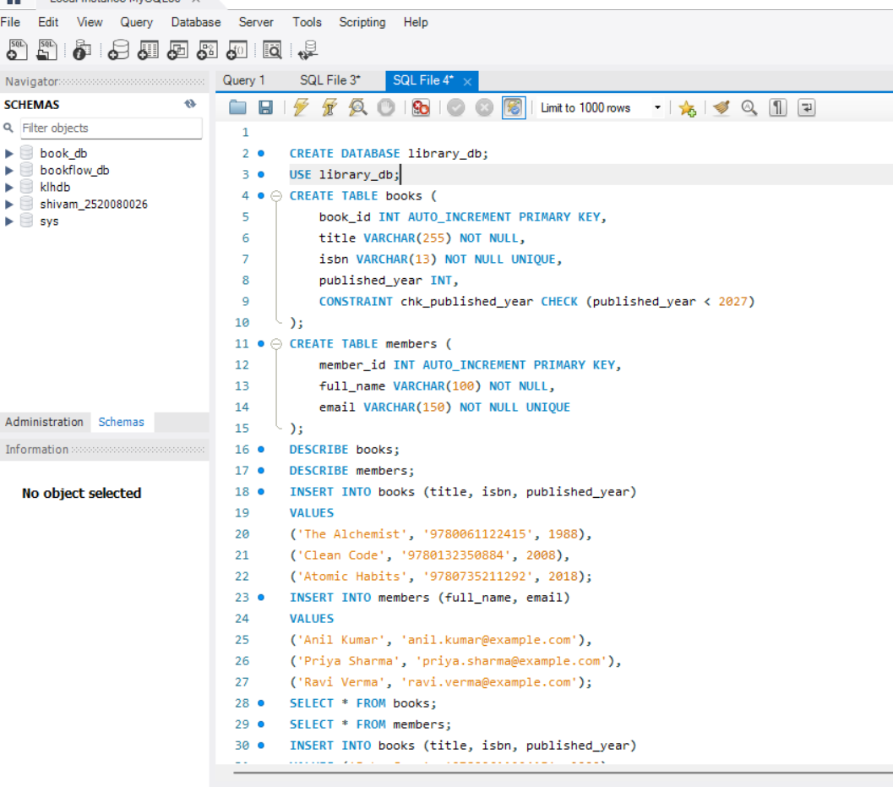
OUTPUT:
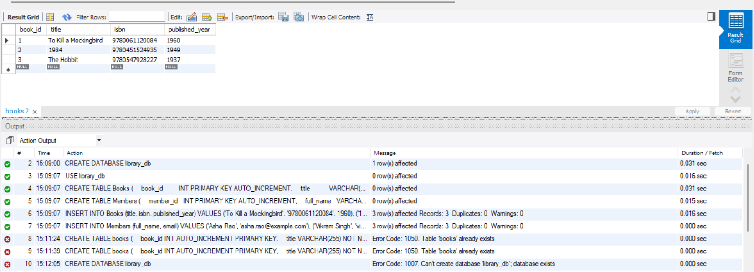
Practical week 2
The Librarian’s Dashboard Scenario The library is now digital! The head librarianneeds a report to see which members are active and which books are in the collection. You also need to handle a "Book Donation" process where a new bookis added and assigned to a category at the exact same time—if one part fails, thewhole process must stop to keep the catalog accurate. Task to be Done 1. TheCatalog Search (JOINs): Create a third table called Loans that connects member_idto book_id. Write a query to show the Member Name and the Book Title they havecurrently borrowed. 2. Collection Stats (Aggregations): Write a query to find thetotal number of books published in each year. o Hint: Use COUNT(book_id) andGROUP BY published_year. 3. The Donation Transaction (ACID): Use aTransaction (BEGIN...COMMIT) to add a new book to the Books table andsimultaneously log the entry in a Donation_History table. 4. Search Speed(Indexing): Create an Index on the isbn column. Explain why searching by ISBN isnow faster for the librarian than searching by Title. Skill Set Gained • RelationalLogic: Connecting independent tables (Books + Members) through a Junction table(Loans). • Analytical SQL: Using GROUP BY to generate business insights. •Atomic Operations: Using Transactions to ensure multiple database changessucceed or fail as a single unit.
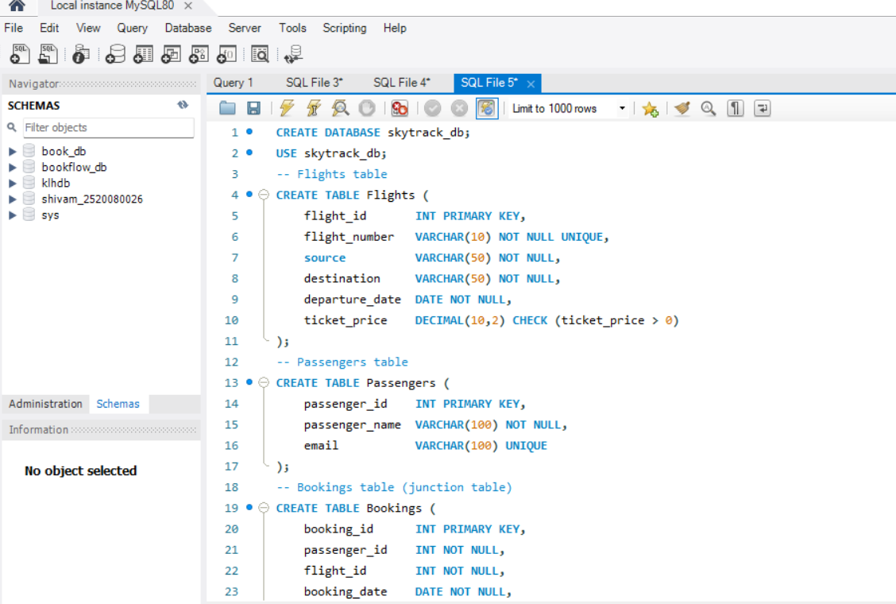
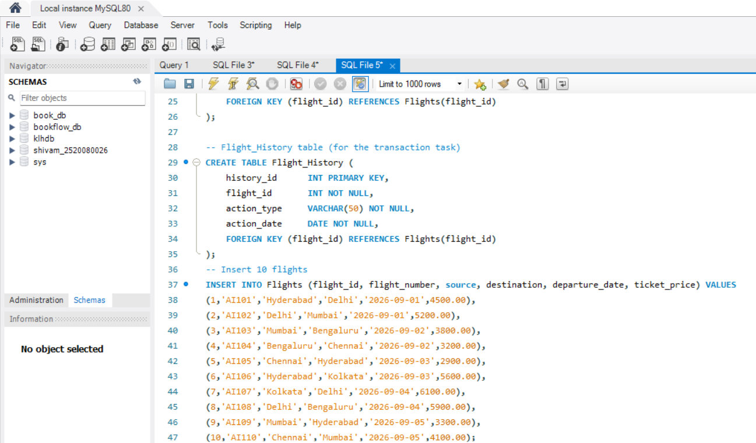
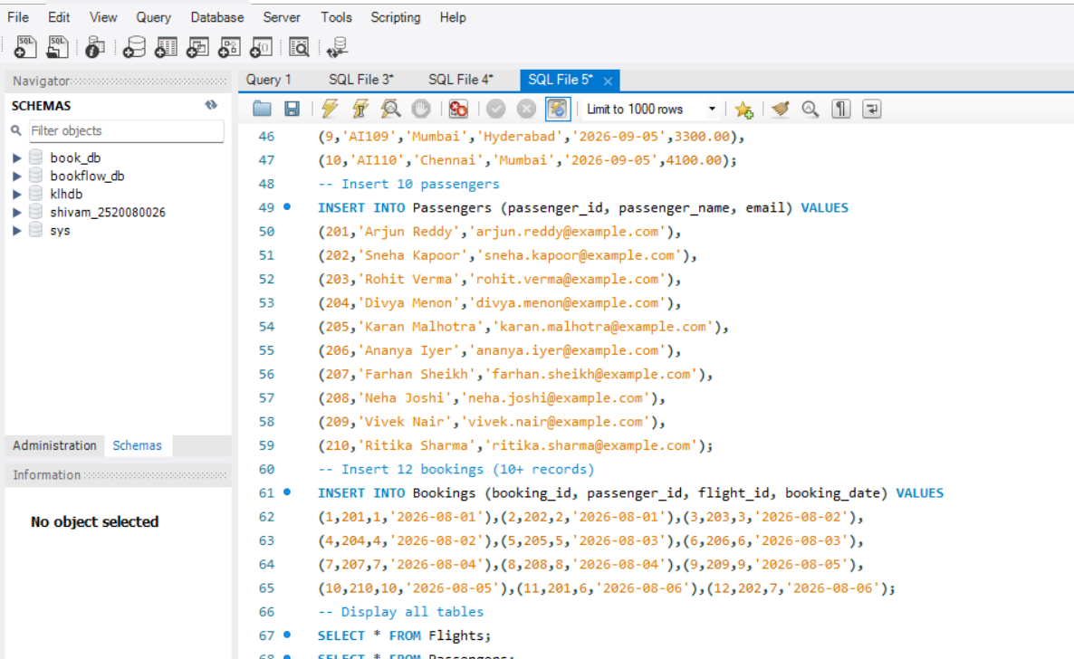
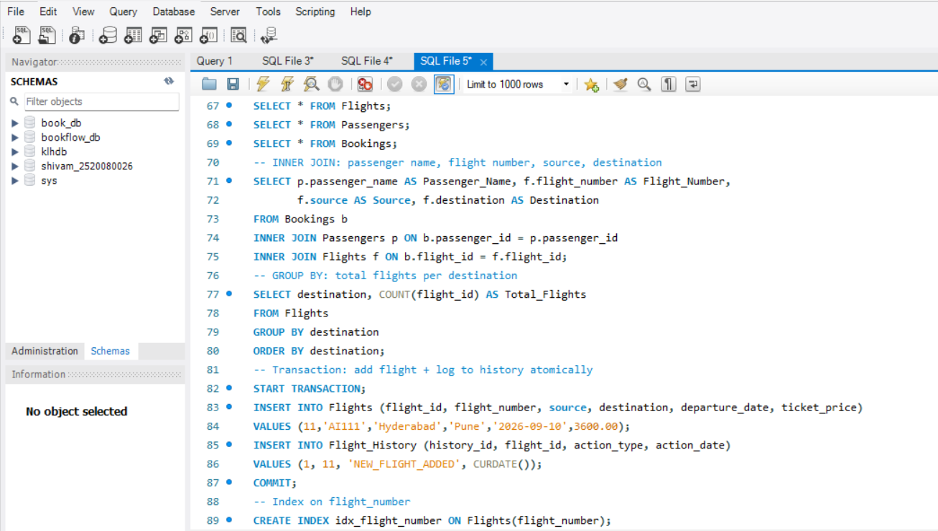
OUTPUT:
